Variables
In an earlier lesson, we printed 'Hello, world!' to the screen by passing that value directly to the print() function. Instead, we could have stored 'Hello, world!' in a variable, then used that variable to print the message:
message = 'Hello, world!'
print(message)
Hello, world!
In this lesson, you’ll learn about the variables included in Python and how to use them in your code. By the end of this lesson, you’ll be able to explain what variables are and how to create them with proper syntax. You’ll also be able to assign different values to a variable and use variables after you create them. Storing data in variables is essential for writing clean and efficient code, so let’s get started!

Creating variables
In programming languages, variables act as containers for other values (text, numbers, etc.). Using variables allows us to save those values for easy reference later.
For example, what if we want to work with the first 100 digits of pi? Typing that long number every time we need it would be a huge task, and we'd probably make mistakes. Instead, we can create a variable to store that number once and then use the variable's name whenever we need the value:
pi = 3.141592653589793238462643383279502884197169399375105820974944592307816406286208998628034825342117067
print(pi + 1)
4.141592653589793238462643383279502884197169399375105820974944592307816406286208998628034825342117067
In the example above, we named our variable pi and used the assignment operator = to store our value in the variable. In other words, we assigned the value 3.14159… to the variable pi. We then used pi to perform a calculation. We only needed to type the long value once — how convenient!
In Python, we can’t create a variable without assigning it an initial value. To do this, we just have to write our variable name followed by the assignment operator =, and then the value that we want the variable to store.
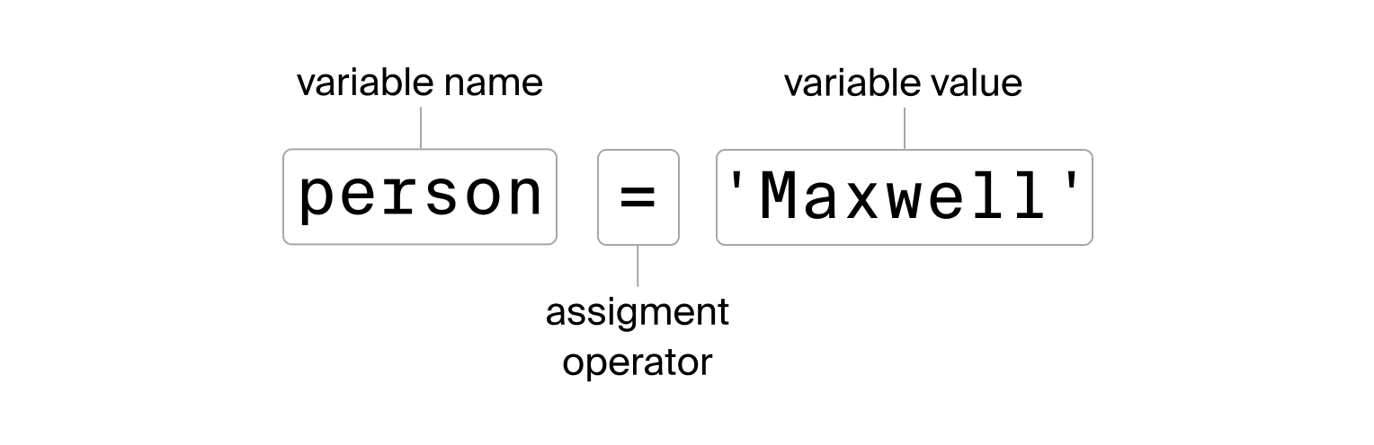Assigning a variable
If we place the variable inside the parentheses of the print() command and run the code, the value of the variable will be displayed on the screen. In programming terms, this is called passing the variable to the print() function:
person = 'Maxwell'
print(person)
Maxwell
Notice that all the variable names we've used so far are descriptive. You should always try to use descriptive variable names so that others who read your code (including future you) can easily understand what values the variables hold.

Changing the value of a variable
Variables are called variables because the values they store can change. To change the value of a variable, simply assign a new value to it:
person = 'Maxwell'
print(person)

person = 'Max'
print(person)
Maxwell
Max
It's important to know that when you assign a new value to a variable, its old value is replaced. Now that person contains 'Max', the old value 'Maxwell' is no longer accessible in later lines of code.
Now it’s your turn. The variable pets stores the number of pets Max has:
pets = 2
But Max has adopted two new cats from the animal shelter. Assign a new value to the pets variable so that the code below prints 4.
Code
python
1
2
3
pets = 2
pets = 4
print(pets)
Variable successfully overwritten!
HintShow solutionSubmit

Variable Syntax
Syntax refers to the rules for how code is written and interpreted. If your code does not have proper syntax, you’ll probably get an error when you run it. Python has the following syntax rules for naming variables:
- Variable names can only begin with letters or the underscore character _.
- Variable names can only contain letters, numbers, and underscores. Other special characters are not allowed.
Question
What do you think this code will print on the screen?
My_Var = 'oh hi'
my_var = 'heeey'
print(My_Var)
oh hi
Good eye!
heeey
Nothing, the code will cause an error.
Excellent!
Variables are such an integral part of coding that you’ll be using them pretty much all the time from here on out. So, let’s get a little more practice before moving on to the next lesson.
The code below contains two variables, one with the name of Steven Spielberg’s first movie and one with the year that movie was released. Use the variables provided inside the print() function to print out this exact message: Steven Spielberg's first movie was Firelight in 1964.
Code
python
1
2
5
first_movie_title = 'Firelight'
first_movie_year = 1964

print("Steven Spielberg's first movie was" , first_movie_title , "in" , first_movie_year)

Basic Math
Now that we know how to create variables and display their values with print(), let’s make things a little more interesting by using variables to perform calculations. This is a very common practice for data professionals!
In this lesson, you’ll learn how to create variables using basic arithmetic operators, and you’ll use these new skills to answer questions about a dataset on websites and languages. This data was estimated using various sources from 2023. Before we get started, take a look at the table below:
Language | Share of websites in top 10mil | Native speakers (mil) | Language speakers (mil)
English | 0.604 | 459.8 | 1350.0
Russian | 0.085 | 156.6 | 265.1
Spanish | 0.040 | 456.1 | 595.1
French | 0.026 | 97.7 | 300.0
German | 0.024 | 96.8 | 136.3
Japanese | 0.021 | 125.1 | 125.5
Chinese | 0.014 | 1310.0 | 1400.0
Italian | 0.008 | 61.6 | 64.9
We’ll use this data to answer the following questions:
- How many people speak either Spanish or English?
- What share of Italian speakers are native speakers?
- How many more native Japanese speakers are there than native French speakers?

Arithmetic operators
To answer these questions with Python, we need to use some basic arithmetic operators:
- + — addition
- - — subtraction
- * — multiplication
- / — division
- ** — exponentiation
These operators work just as you would expect when using a calculator. Run the code below to see for yourself. Feel free to change the numbers and play around with the code.
Code
python
1
2
3
4
5
6
7
8
9
10
11
12
13
14
# addition
print(1.5 + 10)

# subtraction
print(1.5 - 10)

# multiplication
print(1.5 * 10)

# division
print(1.5 / 10)

# exponentiation
print(1.5 ** 10) # 1.5 to the 10th power
Show solutionRun
Notice how we put arithmetic expressions inside print() to display the result. Pretty cool, huh?

Calculations with variables
Now you know how to do basic math calculations in Python. However, the real power of Python comes from using variables to store our results, which we can then use in further calculations.
For example, we can use variables to calculate the total number of people who speak either French or German by adding their values from the 'Language speakers (mil)' column in the dataset from before:
french_speakers = 300.0
german_speakers = 136.3

total_speakers = french_speakers + german_speakers

print("Millions of people who speak French or German:", total_speakers)
Millions of people who speak French or German: 436.3
Using variables, we calculated and displayed our result: 436.3 million people speak either French or German (if we double-count people who speak both).
Let’s try to answer our first question from before: How many people speak Spanish or English? Use the variables in the precode to do your calculation, then assign your result to a new variable called total_speakers and print its value. Here is the table again for reference:
Language | Share of websites in top 10mil | Native speakers (mil) | Language speakers (mil)
English | 0.604 | 459.8 | 1350.0
Russian | 0.085 | 156.6 | 265.1
Spanish | 0.040 | 456.1 | 595.1
French | 0.026 | 97.7 | 300.0
German | 0.024 | 96.8 | 136.3
Japanese | 0.021 | 125.1 | 125.5
Chinese | 0.014 | 1310.0 | 1400.0
Italian | 0.008 | 61.6 | 64.9
Code
python
1
2
3
4
5
6
english_speakers = 1350.0
spanish_speakers = 595.1

# write your code here
total_speakers = english_speakers + spanish_speakers
print(total_speakers)
Almost 2 billion English or Spanish speakers — that’s a lot!
HintShow solutionSubmit
Now that the first question has been answered, let’s tackle the last two.
Our second research question was to find the share of total Italian speakers who are native speakers. Once again, use the variables provided in your code to do your calculation. Assign the result to a variable called share_native and print its value.
Code
python
1
2
3
4
5
6
total_italian = 64.9
native_italian = 61.6

# write your code here
share_native = native_italian/total_italian
print(share_native)
About 95% of Italian speakers are native speakers — that’s a lot too!
HintShow solutionSubmit
Good job, you’re becoming a Python math whiz! Can you use your new skills to answer the last question: How many more native Japanese speakers are there than native French speakers?
Use the provided variables and assign your result to a new variable called speaker_diff, then print its value.
Code
python
1
2
3
4
5
6
native_japanese = 125.1
native_french = 97.7

# finish your code below here
speaker_diff = native_japanese - native_french
print(speaker_diff)
There are over 27 million more native Japanese speakers than native French speakers. You guessed it — that’s a lot!

Error Messages
In the lesson on variables, we mentioned that Python will generate an error if your variable syntax is incorrect. In this lesson, we’ll delve deeper into what that means and how to handle errors when writing Python code.
Python errors can arise for various reasons, but they usually fall into one of these three categories:
- Improper syntax
- Prohibited operations
- References to undefined variables
When your code encounters any of these issues, Python will display an error message and stop running at the line where the problem occurred.
Encountering errors isn't a sign of poor programming skills; it simply means that Python came across something it couldn’t understand or execute. In fact, errors are valuable because they provide clues to help you identify and fix issues in your code, guiding you toward better solutions.

Syntax errors
Let’s see what happens when we try to create a variable with a name that violates the syntax rules. Variables cannot begin with numbers, so this will raise an error.
Code
python
1
2
3
4
5
name_1 = 'Joe'
2_name = 'Mary'

print(name_1)
print(2_name)
Show solutionRun
As expected, we get a SyntaxError. Error messages can be unclear—here, Python thinks we're writing a decimal number instead of a variable. What’s more useful is the line above the error, showing where it happened. The code stops at the syntax error, so the following print() calls aren’t executed.
Besides variable names, many other syntax errors can occur. Run the code below to see examples (uncomment the lines by deleting the #), then fix the syntax and run it again to check for errors.
Code
python
1
2
print('Hi')

Show solutionRun

Operation errors
We can also run into errors when we try to perform “illegal” operations. For example, here’s what happens if we try to divide by zero:
Code
python
1
print(777 / 0)
Show solutionRun
Just like in math, dividing by zero is a no-go in Python. Other kinds of arithmetic operation errors occur when we try to do calculations like adding text to a number:
Code
python
1
2
numbers = 'one two three four' + 5
print(numbers)
Show solutionRun
It doesn’t really make sense to add text to a number, so Python throws an error. Text and numbers are incompatible types for addition. Later in this chapter, we’ll learn more about different data types and their allowed operations.

Namespace errors
Namespace errors are another common type of error. If you try to use a variable that hasn’t been created yet, Python doesn’t know what to do, since the variable doesn’t exist yet in Python’s namespace. Here’s an example:
Code
python
134
apple_price = 1.25
banana_price = 0.99

print("Total price:", apple_price + banana_price + kiwi_price)
Show solutionRun
Python has no idea what we mean by kiwi_price. To fix this, we need to create the kiwi_price variable before we use it in the print() function.
Now that we've looked at common Python errors and how they occur, you're better equipped to handle them when they pop up. Remember, encountering errors is a normal part of learning to code. Each error message is a clue that helps you understand Python better. Keep experimenting and don't be discouraged—every mistake is an opportunity to improve.

Data Types
So far, we’ve discussed values and variables. You’ve likely noticed different kinds of values, like text and numbers. Python distinguishes these using data types, and there are more than just numbers and text!
In this lesson, you’ll learn basic Python data types and how operators behave with each type.

Objects and their types
In Python, every value is an object with a data type. Common types include integers, floats, strings, and Booleans (True/False). Data types determine which operations are possible—e.g., you can’t divide the string 'Hello, world!' by a number.
You don’t need to specify the type when creating an object—Python handles that. However, keeping data types in mind is crucial to avoid errors.

Common data types in Python
Here are examples of the four main types. You’ll work with these often, so get familiar with them.
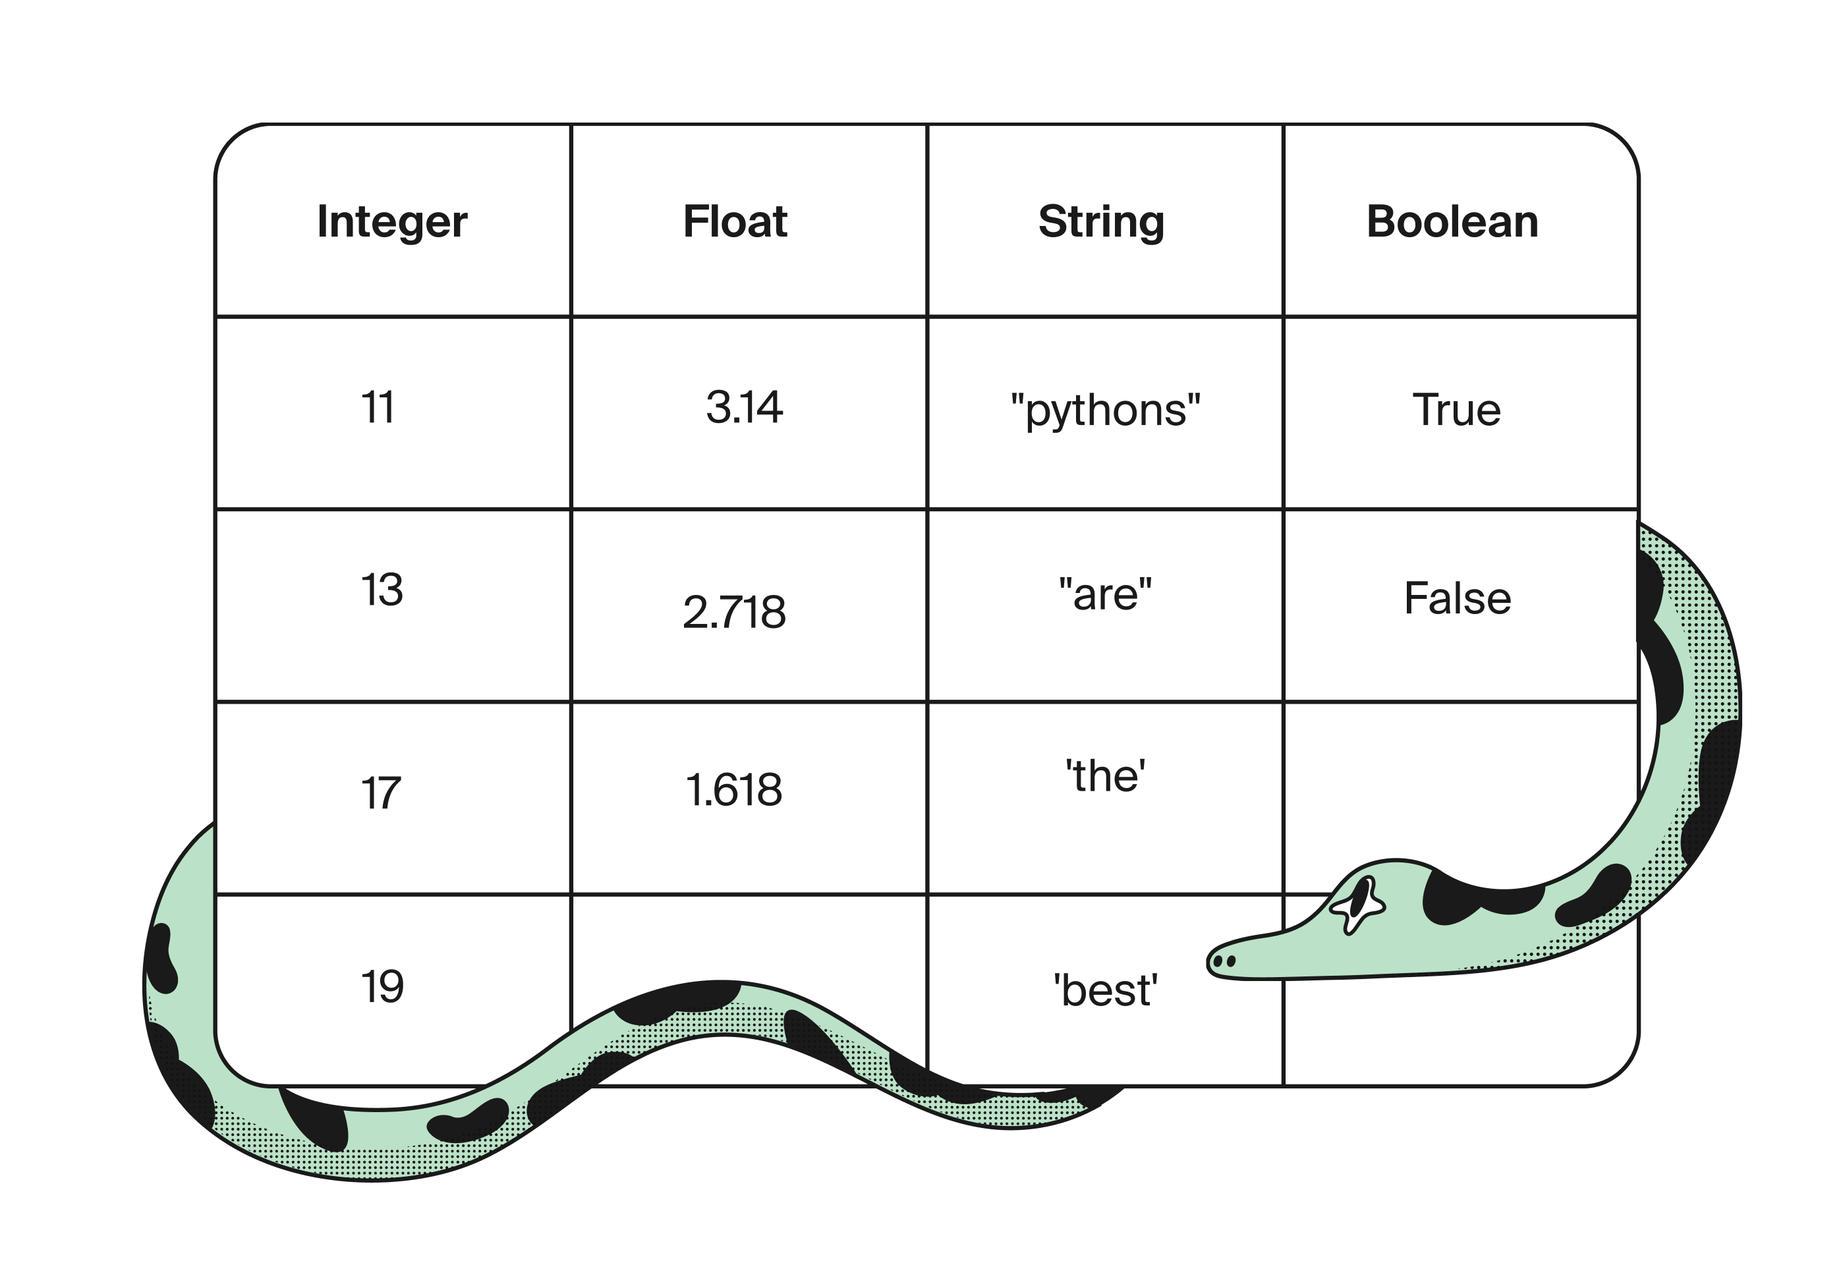

Applying the language data
Let’s go back to the internet language data to explore the operations allowed for the four data types listed above. Here’s the table again as a reminder:
Language | Share of websites in top 10mil | Native speakers (mil) | Language speakers (mil)
English | 0.604 | 459.8 | 1350.0
Russian | 0.085 | 156.6 | 265.1
Spanish | 0.040 | 456.1 | 595.1
French | 0.026 | 97.7 | 300.0
German | 0.024 | 96.8 | 136.3
Japanese | 0.021 | 125.1 | 125.5
Chinese | 0.014 | 1310.0 | 1400.0
Italian | 0.008 | 61.6 | 64.9
We’ll store the data on the Chinese language in a few variables, then use a built-in Python function called type() that returns the data type of whatever value we pass to it. Finish the code below to print the data type of each variable.
Code
python
1
2
3
4
5
6
7
8
9
10
11
language = 'Chinese'
website_share = 0.014
native_speakers = 1310
total_speakers = 1400

print(type(language))
print(type(website_share))
print(type(native_speakers))
# print the data type for total_speakers
print(type(total_speakers))

Show solutionSubmit
Were the results as expected? Here are the data types we obtained:
- language: string (str)
- website_share: floating-point number (float)
- native_speakers and total_speakers: integer (int)

The addition operator
Now let’s see how addition works for different data types. We’ll create a few more variables from the data on English. Then, we'll use the addition operator on variables of each type.
Code
python
1
2
3
4
5
6
7
8
9
10
11
12
13
14
15
16
# strings
ch_language = 'Chinese'
en_language = 'English'

# floats
ch_website_share = 0.014
en_website_share = 0.604

# integers
ch_total_speakers = 1400
en_total_speakers = 1350

print(ch_language + en_language) # add strings
print(type(ch_website_share + en_website_share)) # add floats
print(ch_total_speakers + en_total_speakers) # add integers
print(ch_total_speakers + 1000.00) # add a float to an integer
Show solutionRun
Here are the key takeaways when it comes to the + operator:
- Adding strings concatenates them, which basically means they’re pasted together into one string.
- If you add only integers, the result will be an integer; if you add only floats, the result will be a float.
- If you add an integer with a float, the result will be a float. In fact, any arithmetic operation that includes at least one float will result in a float.
You can also concatenate strings by multiplying them with integers (but not floats). What do you think will happen when you run the code below? Feel free to change the string and integer values to see what happens.
Code
python
1
print(' 123ABC ' * 6)
Show solutionRun
Some operations only work for specific data types. For example, we can’t add numbers to strings. If you try, Python will throw an error:
result = "Chinese is spoken by " + 1400 + " million people worldwide"
...

TypeError: can only concatenate str (not "int") to str
This is an instance of a TypeError, which means the data types are incompatible for the operation. A string can only be added to a string, or a number to a number, but numbers and strings can’t be added to each other.
Converting Data Types
As we learned in the last lesson, the data types of Python objects determine which operations are allowed and how those operations behave. Since operations depend on data types, there are times when we need to convert a value from one type to another in order to perform a certain operation.

For example, numeric data may have been read in from a file as string type: '24'. If we want to use the numeric value 24 for calculations, we first need to convert the string to a numeric type like int or float. By the end of this lesson, you’ll be able to convert between both floats and integers, and between strings and numbers, and recognize when conversion errors happen.

There are three types of conversion functions that we’ll explore in this lesson:

int() — transforms an object to integer type
float() — transforms an object to floating-point type
str() — transforms an object to string type
Let’s use the dataset on website languages again to see how converting data types works in Python.

image

Converting floats to integers
Of the 10 million most popular websites on the internet, we can calculate the amount that are in Russian:

ru_website_share = 0.085
total_sites = 10000000

ru_sites = total_sites * ru_website_share

print(ru_sites)
print(type(ru_sites))
850000.0
<class 'float'>
Python returns the result as a float because ru_website_share stores a float value. But it makes more sense to represent ru_sites as an integer because you can’t have a fraction of a website. Converting ru_sites to integer type will better match what the value represents in real life.

To turn a float value into an integer, we use the int() function:

ru_website_share = 0.085
sites = 10000000

ru_sites = sites * ru_website_share
ru_sites = int(ru_sites)
print(ru_sites)
print(type(ru_sites))
850000
<class 'int'>
The ru_sites variable has been converted from float to int. The older value was replaced when we assigned the result from the int() call back to the variable.

In the example above, we didn’t lose any information by converting ru_sites to an integer because there was only a 0 after the decimal part of the float. Applying the int() function to a float simply drops the fractional part, so any non-zero numbers after the decimal are lost. It does not round the float to the nearest integer, so be careful.

image
int() does not round its result.

Assign the total number of German speakers to the gm_tot_speakers variable and print its value using the code already provided. Then write your own code to convert the variable to int type and print its value again.

Code
python
1
2
3
4
5
gm_total_speakers = 136.3
print(gm_total_speakers)
gm_total_speakers = int(gm_total_speakers)
# write your code here
print(gm_total_speakers)

Now the data is an integer. We did lose some information, though.

Hint

Show solution

Submit
Converting between strings and numbers
We don’t always receive data in the format we may expect. Sometimes, values that we consider to be numbers are stored in Python as strings.

Let’s say we want to do a calculation with a number that’s actually stored as a string:

ch_total_speakers = '1400'

ch_total_speakers = ch_total_speakers + 10
...

TypeError: can only concatenate str (not "int") to str
A TypeError occurs. The data types don’t match the requested operation because the addition of a string to a number is undefined in Python. Even though it’s obvious to us that '1400' represents a number, Python has no idea.

If we want to perform arithmetic with ch_total_speakers, we need to convert it to a numeric data type first. In this case, let’s convert it to an integer:

ch_total_speakers = '1400'
ch_total_speakers = int(ch_total_speakers)

ch_total_speakers = ch_total_speakers + 10
print(ch_total_speakers)
print(type(ch_total_speakers))
1410
<class 'int'>
The string has been converted to a data type that we can work with.

Now it’s your turn to do some data conversion. Run the code below and examine the error message. Then convert the share_english variable to float type and run the code again before submitting your answer.

Code
python
1
2
3
4
5
6
share_english = '0.604'

# write your code here
share_english = float(share_english)
print(type(share_english))
print(share_english + 0.1)

That’s right! We use float() to convert objects to float type.

Hint

Show solution

Submit
Great job, you’re really getting a handle on converting letters into numbers! But there are also situations where we want to do the opposite. For example, data such as zip codes or ID numbers might be better represented as strings than integers since these aren’t quantitative values that we can do math with.

You may have guessed by now, but we can use the str() function to do so:

zipcode = 90210
print(type(zipcode))

zipcode = str(zipcode)
print(type(zipcode))
<class 'int'>
<class 'str'>
Conversion errors
Of course, not every object can be converted from one type or another. How would we convert the string 'Hello, world!' to a float, for example? Here’s what happens if we try:

print(float('Hello, world!'))
...

ValueError: could not convert string to float: 'Hello, world!'
It turns out that only certain strings can be converted to numeric types. The strings have to be number-like for the conversion to work. Any letters or special symbols will cause Python to throw an error.

Question

Given the following variables, which conversions below are allowed in Python? Select all that apply.
my_str1 = 'TripleTen'
my_str2 = '17'
my_int = 123456
my_float = 123.456
Choose as many as you like
str(my_float)

Converting floats to strings is always allowed.

float(my_str2)

This is allowed because my_str2 is unambiguously a number.

int(my_str1)

This is not allowed because my_str1 contains letters.

float(my_int)

Any integer can be converted to a float without any loss of information.

int(my_float)

Any float can be converted to an integer, but some information may be lost.

float(my_str1)

This is not allowed because my_str1 contains letters.

Your grasp of the material is impressive!
Hopefully, now you understand the concept of data types in Python and when/how to convert between them. These concepts will be important to keep in mind as we continue to introduce more complex data types throughout the sprint.

String Structure
Real-world data contains a lot of text. Usernames, addresses, phone numbers, customer reviews, and social media comments are all examples of text data. And as you now know, Python stores text data as strings, so it’s very important to become familiar with this data type.
We’ve already been working with text data, also known as strings. But in this lesson, we’ll go into more detail about how strings work in Python and how to handle more complex strings.

String indexing
Take a look at this string:
string = "Bottom of the 9th"
print(string)
Bottom of the 9th
Nothing new so far; we just created a string variable and printed its value. But let’s examine this more closely.
The string "Bottom of the 9th" is composed of an ordered set of individual characters. We can access each of these characters using its index within the string. For example, let’s just print the first character:
Code
python
1
2
string = "Bottom of the 9th"
print(string[0])
Show solutionRun
To get a character at a particular index, we just put the index in square brackets after the string variable name. Indexing in Python begins at 0, so we need to use [0] to get the first character.
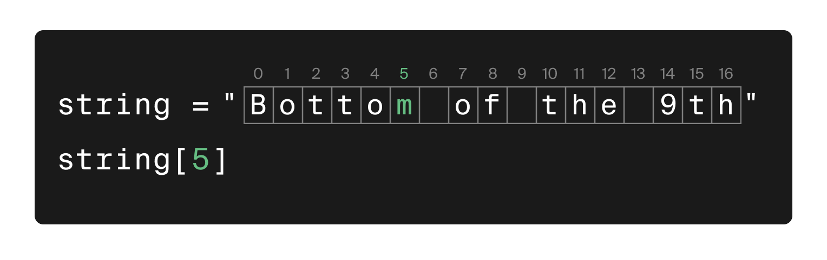Getting the letter “m” from the string
Finish the code below to use indexing to print the 7th character in the string.
Code
python
1
2
3
4
message = "Let's learn about strings!"

# finish the code below to print the 7th character from `message`
print(message[6])
Bingo!
HintShow solutionSubmit

String Slicing
To get a substring slice we put square brackets around the index of the first character we want and the index after the last character we want, separated by a colon. The character at the last index value is not included in the substring.
string[start:end]
- start: The index where the slice begins (included).
- end: The index where the slice ends (excluded).
For example, we can use slicing to extract just the substring "of the" from “Bottom of the 9th”.
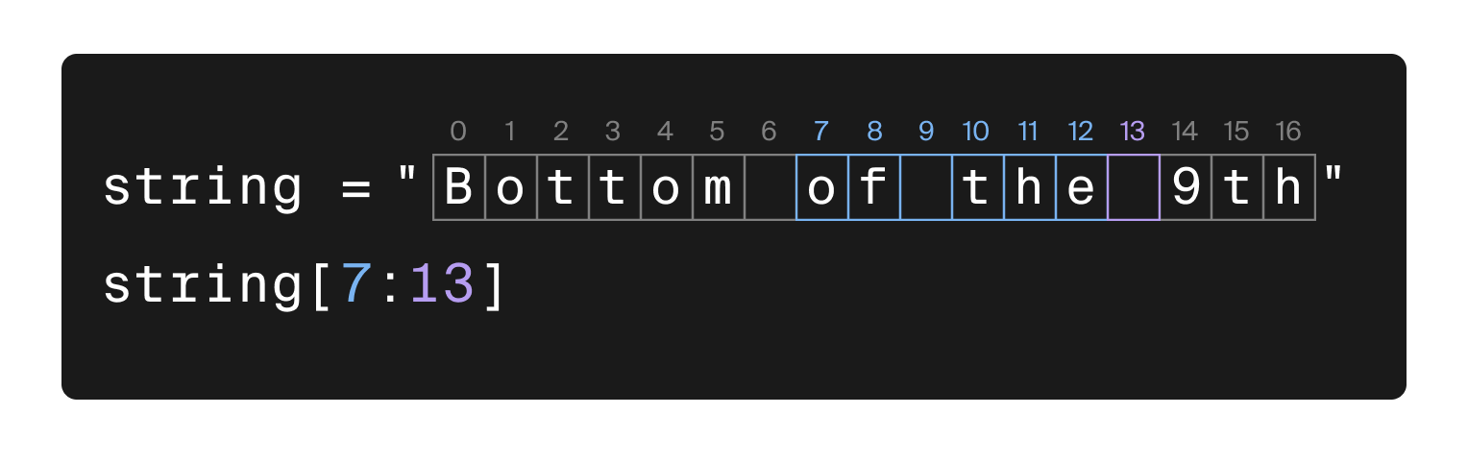
Code
python
1
2
string = "Bottom of the 9th"
print(string[7:13])
Show solutionRun
The slice starts at index 7 (character 'o') and ends just before index 13 (character 'e').
Finish the code below to use indexing to print the substring "learn" from the string variable.
Code
python
1
2
3
4
message = "Let's learn about strings!"

# finish the code below to print the substring learn from message
print(message[6:11])
Zero-indexing and slicing may take some getting used to, but with practice, it’ll become second nature!
HintShow solutionSubmit

String length
The length of a string is equal to the number of characters it has. Strings may be of any length, with the only limitation being the computer’s memory.
Often, we need to know the length of a string for data processing and analysis. Python has a built-in function called len() that we can use to easily calculate the length of any string.
Here’s len() in action:
lullaby = "Twinkle twinkle little star, how I wonder what you are, up above the world so high, like a diamond in the sky, twinkle twinkle little star, how I wonder what you are."

print(lullaby)
print()
print(len(lullaby))
Twinkle twinkle little star, how I wonder what you are, up above the world so high, like a diamond in the sky, twinkle twinkle little star, how I wonder what you are.

166
Could you imagine trying to count the number of characters in this nursery rhyme by hand? Luckily, with len(), it’s not a problem at all!
Use len() to calculate the length of the string variable below and assign the result to a new variable called length. Then print the value of length.
Code
python
1
2
3
4
string = "Olivia needs Max's help."

length = len(string)
print(length)
Did you notice that spaces also count as one character?
HintShow solutionSubmit
As you can see, a Python string is essentially an ordered chain of text characters. Strings have a length equal to the number of characters in the string, and each character is assigned an index value that we can use to extract individual characters or substrings.

Special Characters
Now that you understand how strings are structured, we can discuss how to format strings with special characters.
By the end of this lesson, you’ll be able to use escape characters to format strings and include special characters, and you’ll be able to easily write multi-line strings. You’ll also be able to explain what the empty string is and why you may want to use it sometimes.

Escape characters
In the previous lesson, we worked with the string "Let's learn about strings!", which contains an apostrophe. Since the apostrophe is the same character as a single quote in Python, we had to enclose the string in double quotes to avoid confusion.
But what happens when a string contains both single and double quotes? Consider the following example:
quote = "Britney Spears once said, "She's so lucky, she's a star"."
print(quote)
This code results in a syntax error:
...

SyntaxError: invalid syntax
Switching to single quotes doesn’t solve the problem:
quote = 'Britney Spears once said, "She's so lucky, she's a star".'
print(quote)
Again, we get:
...

SyntaxError: invalid syntax
This results in the same error. The problem here is that Python gets confused by the mixture of single and double quotes. To solve this, we use escape characters.

What Are Escape Characters?
Escape characters allow you to include special characters in strings without causing syntax errors. They are created by using a backslash (\) followed by the character you want to include. Let’s fix our example using escape characters:
quote = "Britney Spears once said, \"She's so lucky, she's a star\"."
print(quote)
This will now correctly print:
Britney Spears once said, "She's so lucky, she's a star".
The backslash \ tells Python to treat the following character as a literal part of the string rather than as code syntax. For example, \" tells Python that the double quote is part of the string itself and not the end of the string.

Common Escape Characters in Python
Escape characters are useful in many situations beyond just handling quotes. Here are some of the most commonly used ones:
- \' — Represents a single quote (or apostrophe).
- \" — Represents a double quote.
- \\ — Represents a backslash itself.
- \n — Creates a new line within the string.
- \t — Adds a tab (indentation) to the text.
Let's see an example using these escape characters to format a string:
print("\tMax's favorite movie is:\nthe last one he watched\n\t\t:D")
This will be displayed as:
Max's favorite movie is:
the last one he watched
:D
In the code, the escape characters \t and \n help structure the text with indentation and new lines, making it more readable.

Multi-line strings
While long lines of text are acceptable to computers, they can be hard for humans to read and maintain. Breaking text over multiple lines improves readability.
Consider this string using escape characters for newlines:
lullaby = "Twinkle twinkle little star,\nhow I wonder what you are,\nup above the world so high,\nlike a diamond in the sky,\ntwinkle twinkle little star,\nhow I wonder what you are."

print(lullaby)
Twinkle twinkle little star,
how I wonder what you are,
up above the world so high,
like a diamond in the sky,
twinkle twinkle little star,
how I wonder what you are.
While the output is formatted nicely, the string in the code is cluttered with \n, making it hard to read.

Using Triple Quotes
Python allows you to write multi-line strings using triple quotes—either ''' or """. This way, the string is formatted in the code just as it will appear in the output.
Rewriting the lullaby using triple quotes:
lullaby = """Twinkle twinkle little star,
how I wonder what you are,
up above the world so high,
like a diamond in the sky,
twinkle twinkle little star,
how I wonder what you are."""

print(lullaby)
Twinkle twinkle little star,
how I wonder what you are,
up above the world so high,
like a diamond in the sky,
twinkle twinkle little star,
how I wonder what you are.
This approach enhances the readability of your code by eliminating the need for escape characters for newlines.

The empty string
An empty string is a string that contains no characters and has a length of zero. It's represented by two quotes with nothing between them: '' or "".
print(type(''))
print(len(''))
<class 'str'>
0
We often use the empty string as a placeholder for missing values in datasets Missing values are pieces of information that should be in the dataset but aren’t there.

Summary
We’ve covered a lot in this lesson! Let’s quickly recap the main points:
- Escape characters like \', \", \\, \n, and \t allow you to include special characters in strings without causing syntax errors.
- Multi-line strings can be created using triple quotes, making it easy to write longer texts in a readable format.
- The empty string is a string with no characters, often used as a placeholder or to indicate the absence of a value.
50 min

Formatted Strings
Up until now, our strings have been pretty static. But with Python, our strings can be much more flexible. F-strings, or formatted strings, can incorporate values from other variables into strings without needing to know what those values are.
By the end of this lesson, you’ll be able to create f-strings to display messages that contain the values of your variable and customize the way numeric variables are displayed in those f-strings. You’ll also be able to explain why it’s better to use variables within strings rather than just typing out the values you want to display.

Incorporating variables into strings
Suppose we want to print a string that tells us a person’s name, age, and height. We could do something like this:
message = "Max is 23 years old and weighs 167.5 lbs."
print(message)
Max is 23 years old and weighs 167.5 lbs.
This code is functional, but if Max’s age or weight ever changes, or if we want to display information for someone else, then we need to remember to change the string as well. It’s much better to use variables instead.
Play around with the variable values below to see how they affect the output when you run the code:
Code
python
1
2
3
4
5
6
name = 'Max'
age = 23
weight = 167.5

message = name + " is " + str(age) + " years old and weighs " + str(weight) + " lbs."
print(message)
Show solutionRun
This is better code because we can now change the string in message just by changing the values of the other variables. It still isn’t ideal though. Creating the message variable is a lot of work here, and we had to convert our numbers to strings to avoid getting an error. Formatted strings make this much easier.

F-strings
We can format strings in Python using f-strings. To create an f-string, we just preface our string with the letter f (think “formatted”) before the opening quotation mark. Wherever we want to place a variable within the string, we use curly brackets {}.
Run the code below to see how f-strings work. Feel free to change the variables to see how they affect the output.
Code
python
1
2
3
4
5
6
name = 'Max'
age = 23
height = 5.7

message = f"{name} is {age} years old and {height} feet tall."
print(message)
Show solutionRun
Isn’t this much easier to work with than the code at the beginning of the lesson?
We can also perform operations, such as arithmetic, within the curly brackets. For example:
name = 'Max'
age = 23

message = f"Next year, {name} will be {age + 1} years old."
print(message)
Next year, Max will be 24 years old.
Now it’s your turn to make an f-string. Use the variables in the code below to create an f-string that will display the following message:
Five years ago, Olivia was 20 years old.
Code
python
1
2
3
4
5
6
name = 'Olivia'
age = 25

message = f"Five years ago, {name} was {age-5} years old."

print(message)
Your strings are so flexible, we could tie them in a bow!
HintShow solutionSubmit

Formatting numbers
We can also use formatted strings to change the way that numeric variables are displayed without changing the variable’s value. For example, sometimes the result of a calculation contains several digits after the decimal, but we might not want to display all of them in our output. Remember the calculation you did to find the share of native Italian speakers in the last chapter? Let’s display that result again using a formatted string:
total_italian = 64.9
native_italian = 61.6
share_native = native_italian / total_italian

message = f"The share of Italian speakers that are native speakers is {share_native}"
print(message)
The share of Italian speakers that are native speakers is 0.9491525423728813
It’s great that Python can calculate results with such precision, but that result isn’t very user-friendly. We can convey this information more clearly by rounding the displayed number to two digits after the decimal. To do this, we can include extra formatting information in the curly brackets.
total_italian = 64.9
native_italian = 61.6
share_native = native_italian / total_italian

message = f"The share of Italian speakers that are native speakers is {share_native:.2f}"
print(message)
The share of Italian speakers that are native speakers is 0.95
After the variable name, we type a colon : followed by the specific numeric formatting code; in this case, .2f. The .2 specifies that we want two digits after the decimal, and the f specifies that we want the number displayed like a typical float value would be. Take a look at this example and see how the output changes:
Now it’s your turn to try it out!
Imagine you went apple shopping and bought 98 of the remaining 203 apples, paying $111 for your purchase. You must really like apples. Below, you’ll find code that has this information across three variables. Using these variables, calculate share_bought and apple_price. Then make changes to message so that your output has the following numeric formatting:
- Display share_bought as a percentage with no digits after the decimal
- Display apple_price as a decimal number with two digits after the decimal
total_price = 111
apples_total = 203
apples_bought = 98

share_bought= apples_bought/apples_total
apple_price = total_price/apples_bought

# make changes to format the numbers
message = f"I bought {share_bought:.0%} of the apples and paid {apple_price:.2f} per apple"
print(message)
That output is fit for a professional report!
25 min

String Methods
In the last lesson, you learned about f-strings and how we can call it on string objects to incorporate variables into our strings. It turns out that Python strings come with a variety of methods, and each one is designed to process strings in a different manner.
Using methods to process strings is a critical part of analyzing and modeling text data. By the end of this lesson, you’ll be able to use some of the most common methods of processing string data:
- upper() — converts all letters to uppercase
- lower() — converts all letters to lowercase
- replace() — replaces parts of a string
- strip() — removes all whitespace

Standardizing letter case
During the data cleaning and processing phases, we often encounter text data that is inconsistent in terms of capitalization. This is important because strings in Python are case-sensitive, meaning Python treats 'Hello', 'hello', and 'HELLO' as three distinct values, even though they represent the same word in human language.
To avoid issues like missing matches or incorrectly counting categories, we need to standardize the capitalization of our text data. By converting all letters to either uppercase or lowercase, we can ensure that strings with different capitalization are treated the same. This step is essential when looking for duplicate values or grouping data by unique categories.
For example, if we had the following list of names: ['John', 'john', 'JOHN'], Python would treat these as three separate entries. However, if we convert them all to lowercase, the list would become ['john', 'john', 'john'], allowing us to correctly identify them as duplicates.
To accomplish this, we can use two methods: upper() and lower(). The upper() method converts every letter to uppercase, while the lower() method converts every letter to lowercase.
Here’s an example for upper():
message = "Hi, my name is Max!"

print(message)
print(message.upper())
Hi, my name is Max!
HI, MY NAME IS MAX!
Just like that, our string is all uppercase!
Note that upper() and lower() do not change the string stored in the variable that they’re called on. If we wanted to replace the value in message above with an all-caps string, then we’d need to reassign the result of calling the methods back to the original variable.
message = "Hi, my name is Max!"

print(message.upper())
print(message)

message = message.upper()
print(message)
HI, MY NAME IS MAX!
Hi, my name is Max!
HI, MY NAME IS MAX!
The lower() method works just the same as upper(). Use lower() to convert the shopping list below to all lowercase letters.
Code
python
1
2
3
4
5
6
7
8
9
10
11
12
13
14
15
shopping_list = '''APPLES
oranges
Lettuce
Tomato
milk
Apples
bread
Ice Cream
apples
OLIVE OIL
Bread'''

# convert the shopping list to lower case here
shopping_list = shopping_list.lower()
print(shopping_list)
I think we may have overdone it on the apples and bread.
HintShow solutionSubmit

Replacing a substring
Another common part of processing text data is removing or replacing parts of strings. For example, maybe we need to fix typos in customer phone numbers or remove domain names from email addresses.
The replace() method is a great tool for removing or replacing substrings. It takes two arguments:
- The substring we want to be replaced
- The string we want to replace it with
Let’s use replace() to correct every time we accidentally misspelled “oil” on this new shopping list:
shopping_list = '''canola oli
olive oil
avocado oil
peanut oli'''

print(shopping_list.replace('oli', 'oil'))
canola oil
oilve oil
avocado oil
peanut oil
Every instance of “oli” in the shopping_list string has been replaced by “oil”.

Removing whitespace
Another common part of processing text data is removing whitespace from the beginning and end of a string. Whitespace includes characters like spaces, tabs, and newlines.
For example, sometimes when data is exported between systems, artifacts such as leading spaces can be introduced in column names. This can make it difficult to write and share code using that data.
The strip() method removes all whitespace characters at the beginning and end of a string, while preserving all whitespace within the rest of the string.
💡 You can also use lstrip() (left strip) and rstrip() (right strip) to just remove whitespace from the beginning (left) or end (right) of the string.
Here’s an example:
column_name = """ purchase date

"""

print(column_name)
print(len(column_name))

print()

print(column_name.strip())
print(len(column_name.strip()))
purchase date

23
-------------
purchase date
13
The whitespace on both ends of column_name has been removed, which is reflected in the different lengths of the strings before and after calling strip().
50 min

Basic Properties of Lists
So far, we’ve worked with data types that have single values. Lists are different because they allow us to store a collection of values within a single data structure. This comes in handy when we have lots of data or when we want to collect similar information in one object, such as names, product IDs, or prices. With lists, we can store many values together, and then pick and choose which values to work with as needed.

Creating a list
Lists are created using square brackets. We can create an empty list using brackets with no values inside:
my_list = []

print(my_list)
print(type(my_list))
print(len(my_list))
[]
<class 'list'>
0
The my_list variable has a data type we haven’t seen before — list! The list is empty, so its length is 0. An empty list isn’t too exciting at this point, so let’s create one with some actual values in it:
favorite_films = ['The Graduate', 'Reservoir Dogs', 'Fear and Loathing in Las Vegas']

print(favorite_films)
print(type(favorite_films))
print(len(favorite_films))
['The Graduate', 'Reservoir Dogs', 'Fear and Loathing in Las Vegas']
<class 'list'>
3
Now we’re getting somewhere! Our list has three items (also commonly referred to as “elements” or “values”). Each item is separated by a comma when we create the list. Even though the items are strings, the list itself has the list data type. The length of the list is 3 because it contains three items.
Also, note that we named the list variable favorite_films because the items in the list are film names. We can name the list whatever we want, but it’s good coding practice for variable names to describe the data they contain.
The items in the favorite_films list are all the same data type, but they don’t have to be. Lists can contain items with different types, and items of any data type are allowed to be in a list — even other lists:
my_list = ['<3', 77, 3.89, True, False, ['sub', 'list', 0.2]]

print(my_list)
print(len(my_list))
['<3', 77, 3.89, True, False, ['sub', 'list', 0.2]]
6
In practice, we don’t often need to mix data types in a list. However, it can come in handy if we want to represent table rows as a list, for example. Notice that the length of my_list is 6. Even though the sublist contains three items, the sublist itself only counts as one item in my_list.
Now it’s time for you to make your own list. Below are some variables that store information about the movie Fight Club. Create a list called movie_info that contains all the variables as items, then print the list.
Code
python
1
2
3
4
5
6
7
8
9
title = 'Fight Club'
year = 1999
genre = ['thriller', 'drama', 'crime']
duration = 139
rating = 8.644

# write your code here
movie_info = [title , year , genre , duration , rating ]
print(movie_info)
Congratulations, you’ve added a new data structure to your tool kit.
HintShow solutionSubmit

Indexing lists
Now that we can make lists, let’s discuss how to access the items a list contains. Like the characters in a string, the items in a list have an ordered index. List indexing also begins at 0 and increases by 1 for each subsequent item.
We can access individual list items just as we did characters in a string:
movie_info = ['Fight Club', 1999, ['thriller', 'drama', 'crime'], 139, 8.644]

print(movie_info[0])
print(type(movie_info[0]))
Fight Club
<class 'str'>
We have selected the first item in the list (i.e., the item and index 0), and we’ve confirmed this by printing its value and its data type.
Now it’s your turn to give it a shot. Print the 3rd item from the movie_info list.
Code
python
1
2
3
4
movie_info = ['Fight Club', 1999, ['thriller', 'drama', 'crime'], 139, 8.644]

# write your code here
print(movie_info[2])
Indexing isn’t so bad, right?
HintShow solutionSubmit

💡By the way!
The rules of indexing lists still apply when lists are also elements in a list, like the genres you see above.
To print the first genre from that list you can run the code:
print(movie_info[2][0])

Slicing
We can slice lists in the same way we slice strings. When we slice a list, Python creates a new list with the selected elements. For example, if we want to extract only the genre and duration from the movie_info list, we can do that using slicing.
movie_info = ['Fight Club', 1999, ['thriller', 'drama', 'crime'], 139, 8.644]

print(movie_info[2:4])
print(type(movie_info[2:4]))
[['thriller', 'drama', 'crime'], 139]
<class 'list'>
Use index slicing to get a list that contains just the 2nd through 4th items in the movie_info list (year, genre, and duration info). Print your result.
Code
python
1
2
3
4
movie_info = ['Fight Club', 1999, ['thriller', 'drama', 'crime'], 139, 8.644]

# write your code here
print(movie_info[1:4])
If you can slice a string, you can slice a list.
HintShow solutionSubmit
If either the first or last item in a list is part of the slice, we can actually use shorthand notation where we omit the first or last index value. For example, we can grab the first three items like this:
movie_info = ['Fight Club', 1999, ['thriller', 'drama', 'crime'], 139, 8.644]

print(movie_info[:3])
['Fight Club', 1999, ['thriller', 'drama', 'crime']]
And if we want to get all of the items after the first two, we could do this:
movie_info = ['Fight Club', 1999, ['thriller', 'drama', 'crime'], 139, 8.644]

print(movie_info[2:])
[['thriller', 'drama', 'crime'], 139, 8.644]

Negative indexing
We can also index starting from the end of this list using negative index values, with the last item in the list having an index value of -1. Negative indexing comes in handy when we just need to reference the last items in a list.
movie_info = ['Fight Club', 1999, ['thriller', 'drama', 'crime'], 139, 8.644]

print(movie_info[-1])
print(movie_info[-2])
8.644
139
Use negative indexing to print the second element from the movie_info list.
5
movie_info = ['Fight Club', 1999, ['thriller', 'drama', 'crime'], 139, 8.644]
# write your code here
print(movie_info[-4])

Modifying Lists
You may have noticed that there are some similarities between lists and strings. However, there is a significant difference that we need to discuss: items in a list can be modified, but characters in a string can’t. In Python terms, we say that lists are mutable, while strings are immutable. Because lists can be modified, they’re great to use when we’re working with data that may change during our analysis.

By the end of this lesson, you’ll be able to change the value of an item in a list, insert additional items using the append() and insert() methods, and remove items from a list using the pop() method.

Replacing items in a list
Since lists are mutable, we are free to reassign any value to any item in a list. Let’s continue using the movie data from the last lesson.
title = 'Fight Club'
year = 2999
genre = ['thriller', 'drama', 'crime']
duration = 139
rating = 8.644

movie_info = [title, year, genre, duration, rating]
print(movie_info)
['Fight Club', 2999, ['thriller', 'drama', 'crime'], 139, 8.644]
Oh no, we made a mistake! The year is supposed to be 1999. To fix this, all we have to do is assign 1999 to the item in movie_info at the correct index.
title = 'Fight Club'
year = 2999
genre = ['thriller', 'drama', 'crime']
duration = 139
rating = 8.644

movie_info = [title, year, genre, duration, rating]
print(movie_info)

movie_info[1] = 1999
print(movie_info)
['Fight Club', 2999, ['thriller', 'drama', 'crime'], 139, 8.644]
['Fight Club', 1999, ['thriller', 'drama', 'crime'], 139, 8.644]
Replace 'apple' with 'orange' in the list below, then print the list.
Code
python
1
2
3
4
5
shopping_list = ['kiwi', 'banana', 'apple', 'orange', 'watermelon']

# write your code here
shopping_list[2]= 'orange'
print(shopping_list)
I guess we’re doubling up on oranges. So long, scurvy!
HintShow solutionSubmit

Adding elements to a list
There are several ways to add items to a list in Python. Next, we’ll cover how to add single items to a list one at a time with two different methods.
- Adding a new item to the end of a list
- Adding a new item at a specific index

Adding items to the end of a list with append()
Like strings, list-type objects in Python come with an assortment of built-in methods that we can call to process lists. The append() method allows us to add a new item to the end of a list.
title = 'The Dark Knight'
year = 2008
genre = 'fantasy, action, thriller'
duration = 152
rating = 8.917

dk_info = [title, genre, duration]

print(dk_info, len(dk_info))
print()

dk_info.append(rating)

print(dk_info, len(dk_info))
['The Dark Knight', 'fantasy, action, thriller', 152] 3

['The Dark Knight', 'fantasy, action, thriller', 152, 8.917] 4
The average movie rating is now at the end of the list, and the length of the list has, of course, increased by 1.
To use append(), all we had to do was pass it the value that we wanted to add to the end of the list. Note that we didn’t reassign the result of calling append() back to movie_list. Rather, append() changes the list itself, so be careful!
Use append() to add the next number in the sequence to the list below. Then, print the list.
Code
python
1
2
3
4
5
count = [1, 2, 3, 4, 5, 6]

# write your code here
count.append(7)
print(count)
Just like that, the list grows.
HintShow solutionSubmit

Adding items at a specific index with insert()
There are times when we may want to insert a new item in a list at a position other than the end. In the Dark Knight example, we forgot to include the year! To keep the movie information format the same as with Fight Club, we need to add the year as the 2nd item in the list.
We can do this with the insert() method. It takes two arguments: the first is the index where we want to insert the value, and the second is the value we want to insert.
title = 'The Dark Knight'
year = 2008
genre = 'fantasy, action, thriller'
duration = 152
rating = 8.917

dk_info = [title, genre, duration]
dk_info.append(rating)

print(f"The list {dk_info} has {len(dk_info)} items.")
print()

dk_info.insert(1, year)

print(f"The list {dk_info} has {len(dk_info)} items.")
The list ['The Dark Knight', 'fantasy, action, thriller', 152, 8.917] has 4 items.

The list ['The Dark Knight', 2008, 'fantasy, action, thriller', 152, 8.917] has 5 items.
The length of the list has once again increased by 1, but this time the index values of all the items after the new one have also increased by 1. Don’t forget to keep this in mind.
Question
What will be the output of the code below?
dark_knight_movie = ['The Dark Knight', 'USA']
dark_knight_movie.insert(1, ['fantasy', 'action', 'thriller'])
print(dark_knight_movie)
['The Dark Knight', 'USA', 'fantasy', 'action', 'thriller']
We’re inserting a list, not the individual items in that list. The index is off here too.
['The Dark Knight', 'fantasy', 'action', 'thriller', 'USA']
We’re inserting a list, not the individual items in that list.
['The Dark Knight', 'USA', ['fantasy', 'action', 'thriller']]
The inserted list is in the wrong position here.
['The Dark Knight', ['fantasy', 'action', 'thriller'], 'USA']
Fantastic job!

Removing an item from a list
Another important way to modify a list is to remove items from it. We can use the pop() method to do this. By default, it removes the element at the end of the list:
movies = ['Matrix', 'Matrix 2', 'Matrix 3']
movies.pop()
print(movies)
['Matrix', 'Matrix 2']
The pop() method actually returns the value it removes, so we can save it in a variable to use it later if we want. We can also remove items at any index by passing that index as an argument to pop().
movies = ['Matrix', 'Matrix 2', 'Matrix 3']

deleted_movie = movies.pop(1)

print(movies)
print(deleted_movie)
['Matrix', 'Matrix 3']
Matrix 2
Remove the genre item from the list below and save it to a variable called genre. Then, observe the output from the print() statements.

Sorting Lists
In the last lesson, you learned how to modify lists by changing, adding, or removing items. In this lesson, you’ll learn how to sort lists, which keeps all its items intact but changes their order. Sorting is great for things like getting a list of names in alphabetical order or a list of dates in chronological order.
By the end of this lesson, you’ll be able to use both the built-in sorted() function and the sort() method to sort lists, and you’ll be able to explain the differences between the two techniques. You’ll also be able to explain what lexicographical sorting is.

The sorted() function
Python has a built-in function called sorted() that can be used to sort a list that we pass to it. The function returns a new sorted list, so we need to reassign the result back to the original list variable if we want to replace the old list.
Let’s sort a list of years in chronological order to see how it works:
years = [1994, 1972, 2008, 1993, 2003, 1994, 1966, 1999, 1962, 1997]

years_sorted = sorted(years)

print(years)
print(years_sorted)
[1994, 1972, 2008, 1993, 2003, 1994, 1966, 1999, 1962, 1997]
[1962, 1966, 1972, 1993, 1994, 1994, 1997, 1999, 2003, 2008]
By default, sorted() sorts from least to greatest, otherwise known as ascending order. But what if we want to go backward through time (in descending order)? We can do that by passing the reverse= named argument and setting its value to True.
💡 Named arguments are one way in which we can pass arguments to functions. We’ll go into greater detail about argument types in the chapter about functions.
years = [1994, 1972, 2008, 1993, 2003, 1994, 1966, 1999, 1962, 1997]

print(sorted(years, reverse=True))
[2008, 2003, 1999, 1997, 1994, 1994, 1993, 1972, 1966, 1962]
Use the sorted() method to sort the movies_duration list below in descending order. Store the result in the movies_duration_sorted variable and print it.
Code
python
1
2
3
4
movies_duration = [142, 175, 152, 195, 201, 154, 178, 139]
movies_duration_sorted = sorted(movies_duration, reverse=True)

print(movies_duration_sorted)
Sorted!
HintShow solutionSubmit

Lexicographical sorting
So far, we’ve just sorted lists of numbers. Let’s try sorting a list of text values this time.
animals = ['Koala', 'antelope', 'Gibbon', 'Alligator', 'manatee', 'Capybara']

print(sorted(animals))
['Alligator', 'Capybara', 'Gibbon', 'Koala', 'antelope', 'manatee']
Hmmm, that’s not quite right… It’s not sorted in alphabetical order! That’s because sorted() sorts text in lexicographical order, which is kind of like alphabetical order except that it takes letter case into account as well as other text characters like numbers and symbols. As we can see, uppercase letters come before lowercase letters in lexicographical order.
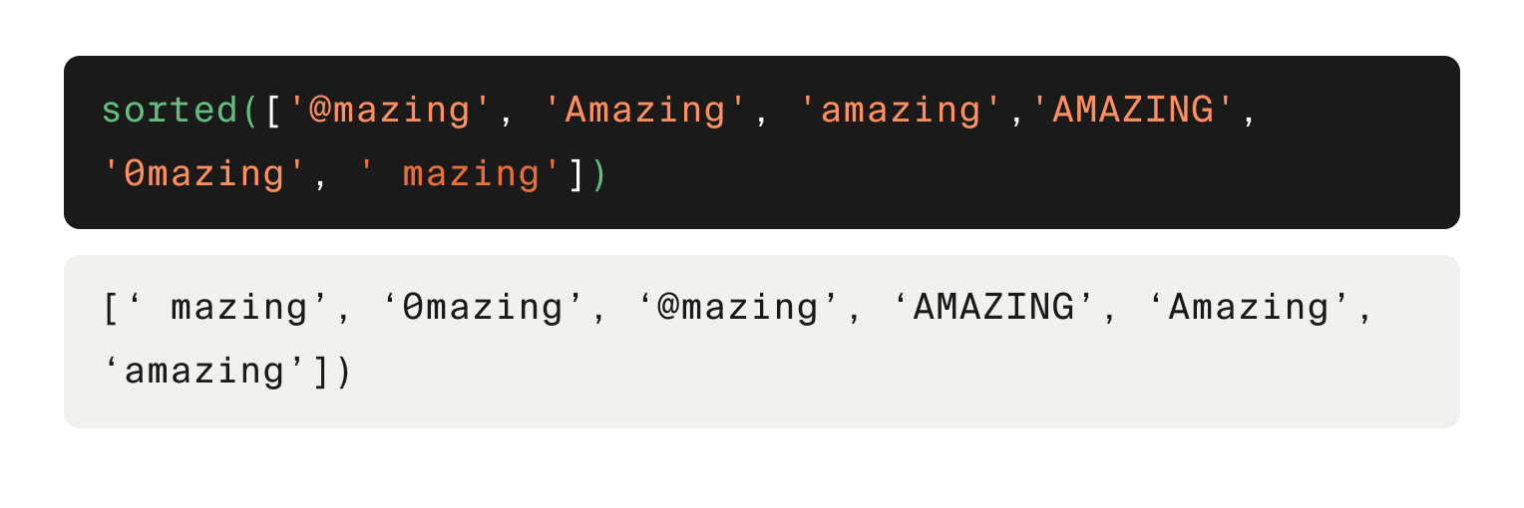
Here is the priority for lexicographical sorting in ascending order:
- Special characters and symbols
- Numbers
- Uppercase letters (A-Z)
- Lowercase letters (a-z)
As we continue to learn more skills in the Basic Python sprint, we’ll discover some strategies to handle the problem of sorting in alphabetical order when we have a mix of uppercase and lowercase letters.
💡 You can also pass a string to sorted(), in which case it returns a list of characters in lexicographical order. Try sorted('3 cats!') to see what we mean!

The sort() method
Another way to sort lists is to call the sort() method on them. Unlike the sorted() function, the sort() method does not return a new object. Instead, it changes the list it’s called on.
Let’s sort the list of years again to show what we mean:
years = [1994, 1972, 2008, 1993, 2003, 1994, 1966, 1999, 1962, 1997]
print(years)

years.sort()
print(years)
[1994, 1972, 2008, 1993, 2003, 1994, 1966, 1999, 1962, 1997]
[1962, 1966, 1972, 1993, 1994, 1994, 1997, 1999, 2003, 2008]
By default, sort() sorts in ascending order. If we want to sort by descending order, pass the reverse=True argument to the method:
years = [1994, 1972, 2008, 1993, 2003, 1994, 1966, 1999, 1962, 1997]

years.sort(reverse=True)
print(years)
[2008, 2003, 1999, 1997, 1994, 1994, 1993, 1972, 1966, 1962]
The sort() method also sorts in lexicographical order.
Use the sort() method to sort the list of movie lengths from shortest to longest, then print the list.

Processing Strings Using Lists
Lists come with some built-in methods that are useful for processing text data, which is why data professionals often transform strings into lists for processing. For example, each character or word in a text can become an element of a list. By separating a string into a list of words, we can take advantage of powerful list methods for processing and analyzing text data, then transform the list back into a string for printing or further analysis.
By the end of this lesson, you’ll be able to use the split() method to break a string into parts, and the join() method to combine them again.

Splitting strings into a list
The split() method can be called on a string to split the string into pieces that are returned in a list. By default, split() splits a string everywhere there’s a space. The characters between the spaces become the elements of the list:
phrase = 'Cuckoo builds a nest!'
words = phrase.split()
print(words)
['Cuckoo', 'builds', 'a', 'nest!']
Each “word” in the list includes all characters between each space, including non-letter characters, and the spaces themselves are not included in any of the list elements.
Now we can do cool things, like calculate the number of words using the len() function:
phrase = 'Cuckoo builds a nest!'
words = phrase.split()
print(len(words))
4
We don’t have to split strings at spaces though; any string can be used as the separator. To specify a separator other than a space, pass it as a string to the split() method:
phrase = 'The * stars * are * out * tonight'
words = phrase.split(' *')
print(words)
['The', ' stars', ' are', ' out', ' tonight']
This flexibility of split() is useful because we’re likely to get data from different sources in different formats. Below is an example of column headers from a data file. Use split() to convert the header text into a list of column names called columns. Print the list.
Code
python
1
2
3
4
5
6
7
8
headers = "date||order_id||product_id||customer_id||quantity||price||shipping_notes"

columns = headers.split('||')
print(columns)

columns = headers.split('||')
print(columns)

Sorted!
HintShow solutionSubmit

Combining a list of strings into one string
Strings are often split into list elements when a text needs to be modified (for example, you can remove repeating words or replace certain fragments). Then the list can be transformed back into a string.
To do this, we can use the join() method. This method is actually a string method, not a list method. We call it on the string that we want to insert between each “word” in the list, then pass the list as input:
words = ['Max\'s', 'favorite', 'film', 'is', 'The', 'Graduate.']
phrase = ' '.join(words) # forms a string from the elements, separated by spaces
print(phrase)
Max's favorite film is The Graduate.
In the example above, we used a space as the character to join the words together. But we can use any string for the joining.
Below is the list with information about Fight Club that you worked with earlier. Use indexing to get the genre element, which is itself a list. Then use join() to create a string from the genre list, where each genre is separated by a comma and a space ', '. Assign the result to a variable called genre, then replace the genre list in movie_info with genre.

Tuples
Python has another data structure, called a tuple, that’s similar to a list. But there are also important differences.
By the end of this lesson, you’ll be able to create tuples, access items within a tuple, and explain the main differences between tuples and lists. You’ll also be able to convert between the list and tuple data types.

Creating and indexing tuples
A tuple is an array-like data structure, just like a list. Tuples can contain any number of items of any data type, and the items are ordered by index position starting at zero.
To create a tuple, we use parentheses rather than square brackets. Here’s an example using the same Fight Club data from before.
movie_info = ('Fight Club', 3999, ['thriller', 'drama', 'crime'], 139, 8.644)

print(movie_info)
print(type(movie_info))
print(len(movie_info))
('Fight Club', 3999, ['thriller', 'drama', 'crime'], 139, 8.644)
<class 'tuple'>
5
As we can see, movie_info has the tuple data type. It looks like a list when we print it, except for the parentheses. It also has a length equal to the number of items it contains, just like lists.
We can also create an empty tuple.
empty_tuple = ()

print(empty_tuple)
print(len(empty_tuple))
()
0
To get an individual item from a tuple, we use the same square bracket syntax with the index of the item we want.
movie_info = ('Fight Club', 3999, ['thriller', 'drama', 'crime'], 139, 8.644)

print(movie_info[2])
['thriller', 'drama', 'crime']
💡 If we want to get an item from a list or tuple within a list or tuple, we can use double indexing. Try this code to see what you get: movie_info[2][1].
We can also get a slice of tuple items the same way we do for lists. The result is a new tuple with fewer elements.
movie_info = ('Fight Club', 3999, ['thriller', 'drama', 'crime'], 139, 8.644)

print(movie_info[1:4])
print(type(movie_info[1:4]))
print(len(movie_info[1:4]))
(3999, ['thriller', 'drama', 'crime'], 139)
<class 'tuple'>
3
Below is a set of variables that contains customer data for an online streaming platform. Create a tuple called data that contains all of the variables in the order they appear, then index the tuple to print just the item that contains the price data.
Code
python
1
2
3
4
5
6
7
8
product = 'annual subscription'
price = 139.99
account = 'premium'
profiles = ('Me', 'Kids', 'Stacey')

# write your code here
data = (product, price , account , profiles )
print(data[1])
Working with tuples is a lot like working with lists!
HintShow solutionSubmit

Tuples are immutable
You may be thinking, what’s the difference between lists and tuples? Why use one over the other?
The main difference is that lists are mutable but tuples are immutable. In other words, lists can be changed but tuples cannot. This means that once a tuple is created, we cannot assign a new value to any of its items.
movie_info = ('Fight Club', 3999, ['thriller', 'drama', 'crime'], 139, 8.644)
movie_info[1] = 1999

print(movie_info)
...

TypeError: 'tuple' object does not support item assignment
💡 Strings are like tuples in that they’re immutable. Try running this code to see what happens: 'dof'[2] = 'g'.
Since tuple items cannot be changed, it’s safer to use tuples instead of lists when we need to be absolutely sure that the data we’re working with won’t be modified anywhere in our code. Tuples are also commonly used to store the output from functions, but we’ll discuss that later.

Converting between lists and tuples
If we’re working with lists but would rather work with tuples to ensure the data can’t be modified, we can use the tuple() function to convert a list to a tuple.
movie_info = ['Fight Club', 1999, ['thriller', 'drama', 'crime'], 139, 8.644]
print(movie_info)
print(type(movie_info))
print()

movie_info = tuple(movie_info)
print(movie_info)
print(type(movie_info))
Show solutionRun
We can also convert tuples to lists using the list() function.

for Loops
As a data professional, you’ll often need to write code that processes large amounts of data. We’re talking thousands to millions of values. For example, imagine you need to update customer information in a database or apply formatting changes to a dataset of email addresses.
These types of problems are easily solved by writing loops in our code that process each value the same way. A computer can accomplish these repetitive tasks millions of times in just a few seconds.
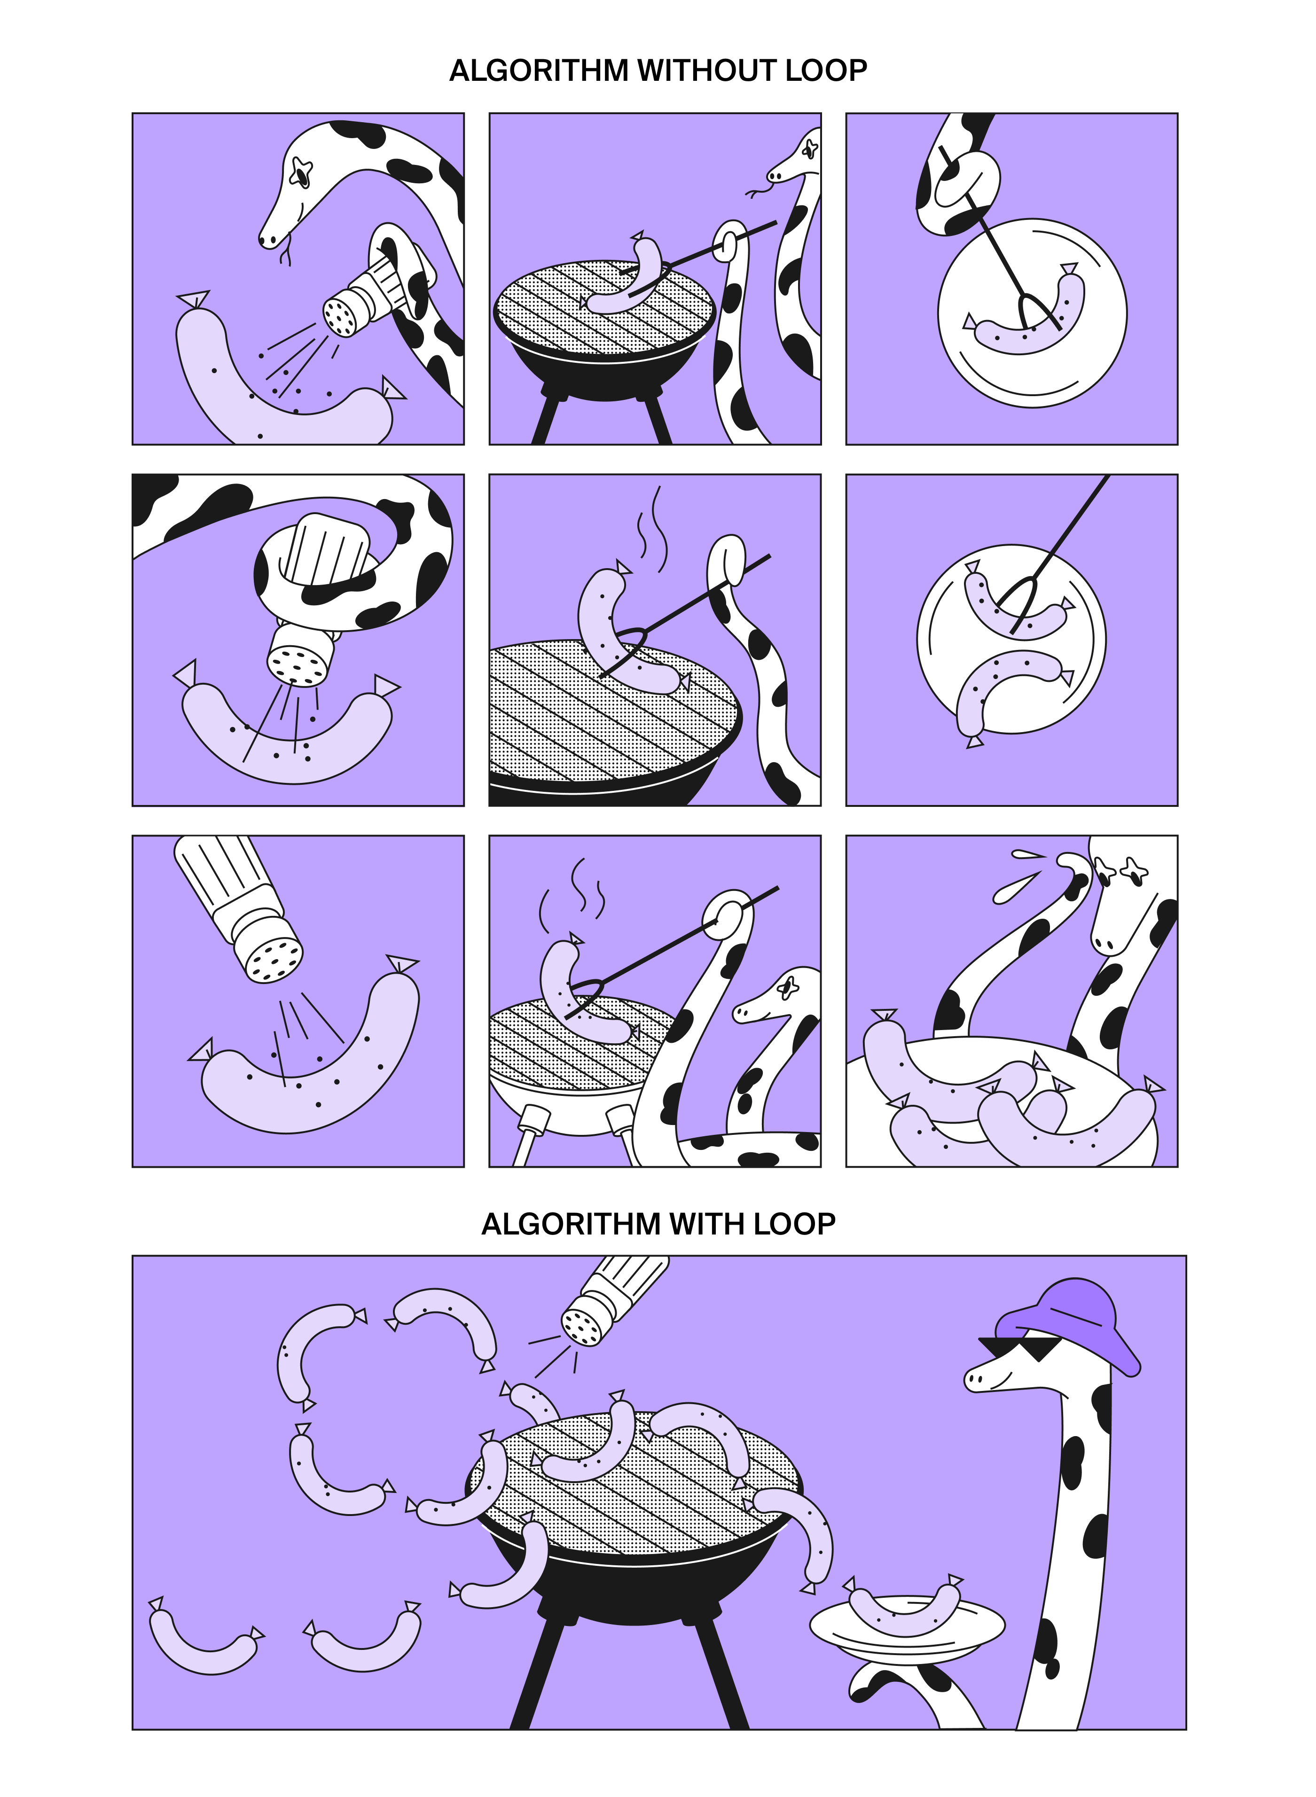

for loops
A for loop in Python helps you repeat the same task for each item in a list, string, or other collections. Think of it as a way to say, "For every item in this group, do this action."
For example, let’s say we have a list of movie genres:
film_genres = ['SCIFI', 'drama', 'Thriller', 'comedy', 'Action']
We can use a for loop to go through each genre and print its name. The typical structure for a for loop is as follows:
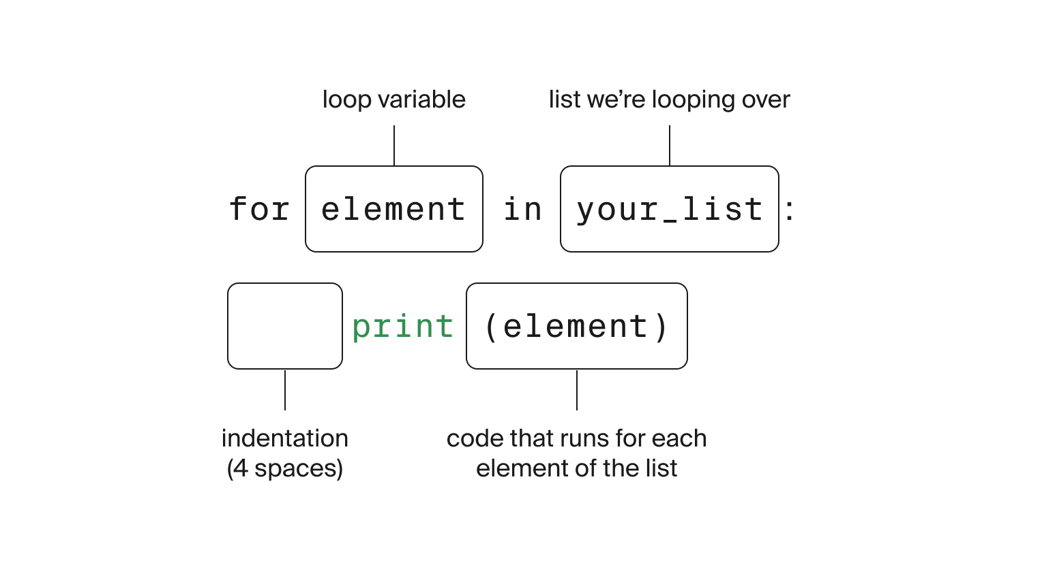
As the image shows, the for loop consists of:
- A loop variable (in this case, genre), which takes on each item in the list one by one.
- A list or collection to loop over (here, film_genres).
- The colon (:), which tells Python to expect indented code below that will run for each item.
- Indented code that will run repeatedly for each item in the list.
Now, let's apply this structure to our example.
Here’s what happens:
- The loop starts with the first genre in the list: SCIFI.
- It runs the code inside the loop. The genre variable takes on a new values with each loop.
- The value of genre gets printed.
- It continues until it reaches the last genre: Action, and prints "Action". The loop is finished because there are no more variables to print.

Loop Techniques
Loops are used in programming for a lot of different tasks, not just for processing data. In this lesson, we’ll explore some common loop techniques to help you get more out of your loops.
By the end of this lesson, you’ll learn:
- How to use the range() function to loop through a set of numbers.
- How to set up and initialize a variable before a loop starts.
- How to use counters to track how many times something happens during a loop.

The range() function
Sometimes, instead of looping through items in a list, we might want to repeat an action a certain number of times. To do this, Python provides the range() function, which allows us to specify how many times the loop should run.
The loop runs 10 times because range(10) generates numbers from 0 to 9 (10 is not included).
By default, when range() has a single argument, it starts at 0 and goes up to (but does not include) the number you specify.

Custom Start Points with range()
If you want the loop to start at a different number, you can provide two arguments to range():
Code
python
1
2
for i in range(5, 10):
print(i)
Show solutionRun
In this case, the loop starts at 5 and runs until it reaches (but does not include) 10, producing numbers 5 through 9.

Modifying Lists In-Place with range()
In the previous example, we looped through a range of numbers and printed them. But what if we want to modify elements in a list instead of just printing them? For instance, let's say we want to convert all items in a list of film genres to lowercase.
To update the items directly in the original list, we can combine range() with the len() function. This allows us to loop through the list using the index of each item, making it possible to assign the processed values back to their original positions.
Here’s how this can be done:
film_genres = ['SCIFI', 'drama', 'Thriller', 'comedy', 'Action']

for i in range(len(film_genres)):
film_genres[i] = film_genres[i].lower()

print(f"Processed data: {film_genres}")
Processed data: ['scifi', 'drama', 'thriller', 'comedy', 'action']
Using range(len(film_genres)) generates a sequence of indices from 0 to len(film_genres) - 1. These indices provide direct access to each element's position in the list. By referencing the index, you can update each element in place, ensuring that changes persist in the original list.

Initialization
When working with loops, it's often necessary to initialize a variable or data structure before the loop starts. This is essential when you need to accumulate results or construct new data that changes with each iteration. For example, you might want to sum up sales figures from a list or generate a new list based on transformations applied to the elements of another list.
To handle these scenarios, you initialize the variable or collection outside the loop. This ensures that the variable has a starting value and is ready to be updated as the loop runs.
Here’s an example:
sales = [100, 200, 150, 175, 300]
total_sales = 0 # Initialize the total sales variable

for sale in sales:
total_sales = total_sales + sale # Add each sale to the total

print(f"Total sales for the month: {total_sales}")
Total sales for the month: 925
In this case, total_sales is initialized to 0 before the loop begins. The loop then adds each sale to the total, updating the total_sales variable with each iteration.
Similarly, if you need to build a new list:
numbers = [1, 2, 3, 4, 5]
squared_numbers = [] # Initialize an empty list

for num in numbers:
squared_numbers.append(num ** 2) # Add the square of each number to the list

print(f"Squared numbers: {squared_numbers}")
Squared numbers: [1, 4, 9, 16, 25]
Here, squared_numbers is initialized as an empty list, and the loop populates it with the squares of the original numbers.
Initialization is a fundamental step that ensures your program starts with a clean slate and updates the variable correctly as the loop progresses.

Task
In the code below, the string wrong_message is backward! Initialize an empty string variable called message, then write a loop that iterates over the characters in wrong_message and concatenates them with message such that the characters are in the correct order after the loop is finished. Print message after the loop to make sure you got it right.
Code
python
1
2
3
4
5
6
7
wrong_message = "!emocleW"
message = "" # empty string
for character in wrong_message:
message = character + message # To add characters to a string, use string concatenation, like message = character + message
print(character + message)

# write your code here
Even if that one was a bit tricky, it goes to show what cool things loops can accomplish.
HintShow solutionSubmit

Using counters
When working with loops, we often have to keep track of how many times something happens over all of the loop iterations. The idea is to initialize the counter outside of the loop and then increment it within the loop:

Logical Expressions
In Python, expressions that evaluate to Boolean values—True or False—are known as logical expressions. These expressions are fundamental in programming, allowing your code to make decisions based on certain conditions. While we'll delve into using logical expressions for decision-making in the next lesson, this chapter focuses on exploring them in detail.
By the end of this chapter, you will be able to:
- Identify and understand Python's comparison and logical operators.
- Explain predicate functions and their applications.

Types of logical expressions
Below is a set of logical expressions in Python:
print(True)
print(False)
print(5 < 3)
print('TripleTen' == 'tripleten')
print('TripleTen'.islower())
print('tripleten'.islower())
True
False
False
False
False
True
Each expression evaluates to either True or False. For instance, 'TripleTen' == 'tripleten' returns False because Python is case-sensitive, confirming that these two strings are not equal—a point even our Marketing Team agrees on!

Breakdown of Logical Expressions
- Comparison Operators: Use symbols like ==, !=, >, <, >=, <= to compare values.
- Logical Operators: Include and, or, not, and in to combine or invert Boolean values.
- Predicate Functions: Built-in functions that return Boolean values, such as .islower() or .isupper().

Comparison operators
Python provides six primary comparison operators. These operators compare two values and return True or False based on the comparison. Here's a summary:
Operator | Name | True Example | False Example
> | Greater than | 7 > 6 | 6 > 6
>= | Greater than or equal to | 6 >= 6 | 6 >= 7
< | Less than | 6 < 7 | 6 < 6
<= | Less than or equal to | 6 <= 6 | 7 <= 6
== | Equals | 6 == 6 | 6 == 7
!= | Not equals | 6 != 7 | 6 != 6
We can also compare strings using comparison operators. The > and < operators aren’t often used with strings, but they work by comparing two strings character-by-character, checking which comes first in lexicographical order. It’s much more common to use == or != with strings.
Question
Select all statements that return true.
Choose as many as you like
10 == 10
Correct! This statement uses the equality comparison operator (==) to check if 10 is equal to 10, which is true.
5 != 3
Correct! This statement uses the inequality comparison operator (!=) to check if 5 is not equal to 3, which is true.
20 > 15
Correct! This statement uses the greater-than comparison operator (>) to check if 20 is greater than 15, which is true.
7 < 3
50 >= 50
Correct! This statement uses the greater-than-or-equal-to comparison operator (>=) to check if 50 is greater than or equal to 50, which is true.
10 <= 5
Fantastic job!

Compound logical expressions

Logical expressions become more powerful when combined using logical operators. Imagine you're working for an online retailer wanting to analyze sales data for:
- Customers who made purchases of at least $200 within the past two weeks.
- Customers residing in the U.S. or Canada.
To achieve this, you can combine multiple logical expressions using and, or, and not :
- and: Returns True only if both expressions are True.
- or: Returns True if at least one expression is True.
- not: Inverts the Boolean value of the expression it precedes.
Here’s a quick example:
print(False and True) # False
print(False or True) # True
print(not True) # False
print(not False) # True

Order of Operations
Python evaluates logical operators in the following order:
- not
- and
- or
When combining multiple expressions, especially complex ones, using parentheses can clarify the intended order of evaluation and prevent unexpected results.
Let’s look at an example where we would want to retrieve customer data only if the customer is named Steven or Carol and they are 30 years old or younger.
Without Parentheses:
name = 'Steven'
age = 40

if name == 'Steven' or name == 'Carol' and age <= 30:
print("Retrieving customer data...")
Retrieving customer data...
Issue: Due to operator precedence, the condition evaluates as name == 'Steven' or (name == 'Carol' and age <= 30). Since name == 'Steven' is True, the entire condition becomes True regardless of the age, leading to unintended behavior.
With Parentheses:
name = 'Steven'
age = 40

if (name == 'Steven' or name == 'Carol') and age <= 30:
print("Retrieving customer data...")
By adding parentheses, the condition now correctly checks if the name is Steven or Carol and if the age is 30 or younger.

Checking for existence
Often, you need to verify whether a specific value exists within a collection, such as a list or a string. Python's in keyword facilitates this.
Syntax:
value in collection
- If the value is found: Returns True
- If the value is not found: Returns False
Examples:
print('com' in 'www.gmail.com') # Output: True
print('com' in 'www.usda.gov') # Output: False
print(3 in [1, 3, 5, 7, 9]) # Output: True
print(3 in [0, 2, 4, 6, 8]) # Output: False
In these examples:
- 'com' in 'www.gmail.com' returns True because the substring 'com' exists.
- 'com' in 'www.usda.gov' returns False because 'com' is not present.
- 3 in [1, 3, 5, 7, 9] returns True as the number 3 is in the list.

Conditional Statements
Now that we've mastered loops and logical expressions, let's explore conditional statements. These allow our code to make decisions based on whether certain conditions are met.
By the end of this lesson, you will be able to explain what conditional statements are, use them to control the flow of your Python code, implement them effectively within loops, and construct decision-making logic with if, elif, and else to handle multiple conditions.

What are Conditional Statements?
A conditional statement allows your code to choose which block to run based on whether a condition is true or false. In Python, you use if to start this decision-making process. If the condition is True, the code inside the if block runs. If it’s False, Python skips that block entirely.
Here’s a simple example:
name = 'Steven'

if name == 'Carol':
print("Hello again, Carol!")

if name == 'Steven':
print("Welcome, Steven!")
Welcome, Steven!

How It Works:
- The first if checks if name == 'Carol'. Since this is False, nothing happens.
- The second if checks if name == 'Steven', which is True, so it prints "Welcome, Steven!"

Structure Breakdown:
- Each if statement ends with a colon :.
- The code inside the block is indented, indicating that it runs only if the condition is true.

Introducing the else Statement
What if you want to handle different outcomes without checking each one separately? You can use an else block that runs when none of the if conditions are true.
Let’s look at an example:
name = 'Steven'

if name == 'Carol':
print("Hello again, Carol!")
else:
print(f"Welcome, {name}!")
Welcome, Steven!
Here, if the condition in the if statement isn't met, the code under else is executed. This ensures that one of the two blocks runs, but not both.

Handling Multiple Conditions with elif
Want to handle more than two possible outcomes? Enter elif (short for else-if), which allows us to check additional conditions between if and else:
name = 'Steven'

if name == 'Carol':
print("Hello again, Carol!")
elif name == 'Steven':
print("Top of the morning to you, Steven!")
else:
print(f"Welcome, {name}!")
Top of the morning to you, Steven!
Key Points:
- if: Tests the first condition.
- elif: Checks additional conditions if previous ones are False.
- else: Runs if all the previous conditions are False.
Note: Only the first condition that evaluates to True will run. Once Python finds a true condition, it skips the rest of the elif and else blocks.

Importance of Condition Order
The order of your conditions in an if-elif-else chain is crucial because Python stops checking further conditions once it finds one that is True.
Consider this example:
x = 50

if x < 10:
print('low')
elif x < 500:
print('high')
elif x < 100:
print('medium')
else:
print('mega')
high
Explanation:
- x < 10 is False.
- x < 500 is True, so it prints 'high' and skips the remaining conditions.
- Even though x < 100 is also True, it isn’t checked because the earlier condition was satisfied.
Pro Tip: Always arrange your conditions from the most specific to the most general to ensure the correct block executes.

Combining Conditions with Logical Operators
Logical operators allow you to check multiple conditions in one statement. You can use:
- and to ensure both conditions are true.
- or to check if at least one condition is true.
- not to invert a condition.
Imagine you're developing a program that determines the ticket price for visitors at a theme park based on their age and whether they have a membership. Here's how we can handle that with logical operators:
age = 16
is_member = True

if age < 12 or age >= 65:
print("You get a free entry!")
elif age >= 12 and age <= 18 and is_member:
print("You get a discounted entry!")
else:
print("You pay the regular entry fee.")
You get a discounted entry!
How it works:
- The or operator checks if the visitor is either under 12 years old or 65 and over for free entry.
- The and operator ensures that both conditions (age between 12 and 18 and is a member) are true for a discounted entry.

Task
Below is a variable called sept_sales that contains the September sales from a business. Write a set of conditional statements that print:
- 'low sales' if the sales were below $30,000
- 'okay sales' if the sales were at $30,000 or above, and below $100,000
- 'good sales' if the sales were $100,000 or above

Combining Conditionals and Loops
Now that we understand basic conditional statements, let’s dive deeper into how to make your Python code smarter by combining conditions using logical operators and nesting conditional statements.
Conditional statements are powerful on their own, but by using them together with loops and logical operators, you can write even more dynamic and flexible code. By the end of this lesson, you will learn how to merge multiple conditions, nest them for more complex scenarios, and incorporate them into loops.

Nested Conditionals
Sometimes, a simple set of if and else statements isn’t enough to capture all the nuances of your logic. That’s when nested conditionals come in handy. You can place an if block inside another to handle more complex decisions.
For example, let’s say we're deciding on the type of clothing advice to give based on the temperature and weather:
temperature = 75
weather = 'sunny'

if temperature > 80:
if weather == 'sunny':
print("It's hot and sunny! Wear light clothing.")
else:
print("It's hot but not sunny. Stay cool!")
else:
if weather == 'sunny':
print("It's a pleasant day. Enjoy the sun!")
else:
print("It's cool and not sunny. You might need a light jacket!")
It's a pleasant day. Enjoy the sun!
How it works:
- The if temperature > 80: condition checks if the temperature is greater than 80. If true, it enters this block to give specific advice based on the weather.
- If the temperature is not greater than 80, the code moves to the else: block. Here, it checks the weather variable to determine the appropriate advice.
- Since the temperature is 75 and the weather is 'sunny', it prints "It's a pleasant day. Enjoy the sun!".

Using Conditional Statements with Loops
One of the most powerful features of conditional statements is how they work inside loops. For instance, you might want to filter through a list of numbers and process them differently based on their value.
numbers = [5, 20, 15, 3, 10]

for num in numbers:
if num < 10:
print(f"{num} is small!")
elif num < 20:
print(f"{num} is medium!")
else:
print(f"{num} is large!")
5 is small!
20 is large!
15 is medium!
3 is small!
10 is medium!
In this loop:
- Each number is checked against the conditions.
- The appropriate message is printed for each based on its value.
Bringing It All Together
Let’s combine all the concepts we’ve learned into an example to see how conditions, loops, and counters work together. This time, we'll use a list of words and check their length. If a word is shorter than 5 characters, we'll convert it to uppercase. We'll also keep track of how many words were changed.
words = ['cat', 'elephant', 'dog', 'hippo', 'bee', 'antelope']

# Initialize a counter variable to track how many words were changed
k = 0

# Loop through each index in the words list
for i in range(len(words)):
# Check if the word's length is less than 5 characters
if len(words[i]) < 5:
# If it is, convert the word to uppercase and assign it back to its index in the list
words[i] = words[i].upper()
# Increment the counter since we made a change
k = k + 1

# Print the number of words that were changed and the updated list of words
print(f"There were {k} words with less than 5 characters")
print(words)
There were 3 words with less than 5 characters
['CAT', 'elephant', 'DOG', 'hippo', 'BEE', 'antelope']
How it works:
- We loop over each index of the words list using range(len(words)) to access each word.
- The condition if len(words[i]) < 5: checks if the word at that index has fewer than 5 characters.
- If the condition is true, we convert the word to uppercase and reassign it to the same index in the list.
- We also increment the counter k by 1 each time a word is changed to track how many words were modified.

Task
Write a loop below that goes over the indices of the animals list and checks whether each one has an uppercase letter in its name. If it does, convert the item at that index to lowercase. Also, initialize a counter variable k before the loop and increment it by 1 every time you convert a name to lowercase. There is already precode that will print your result.
Code

